 Baylor University
Office of Strategic Planning and Improvement

Strategic Planning

Proposal Template

Customized Project Office ™

Environment

Note to the Reader

You are encouraged to tailor this template and make additions or subtractions, as your professional judgment deems necessary. This template is only a suggestion, and should not be viewed as a rigid requirement for you to follow. The scope and complexity of your proposal will drive the actual narrative that you offer as support for its adoption.

Through this activity, keep in mind that this document is central to a successful project proposal and requires thoughtful deliberation, meaningful participation and careful documentation. This document will reside within the BU Strategic Planning Database and will be viewed by all Executive Council members as an important component in their scoring task.

While using this template, please be aware that italicized text indicates instruction, direction, or a suggestion.

General Directions

Your completed proposal should consist of a narrative and a series of supporting documents. Since each proposal is a specific request, not all proposals will require that you complete all forms. The supporting documents that you might need to complete and that will accompany the proposed project include:

1. Personnel
1.1. Staff
1.1.1. Personnel Action Form (PAF) (bupp831a.pdf)
1.1.2. Position Analysis Questionnaire (PAQ) (paq.pdf)
1.2. Faculty
1.2.1. Faculty Position Action Form (FPAF) (fpaf.pdf)

2. Budget
2.1. Budget Template (Pro Forma Budget Template.xls)

3. Strategic Planning
3.1. Strategic Planning Proposal Template - a suggested framework for the narrative justification for the proposed initiative within the context of Baylor 2012 in (SPPtemplate.doc)

The narrative template is the body of the proposal plan. It contains questions divided into several sections. These sections appear as “tabs” within the Project Office™ strategic planning database, and your narrative included in this document should serve as support for the impact scores that you report in the database. Work through the sections in any order you like, except for the Executive Summary which we suggest be completed last. Skipping questions that you do not believe apply to your type of proposal will hinder the Executive Council in their assessment and possible adoption of your proposed initiative. Depending upon your request(s), the areas of Academic Services, Budget and Financial Planning, Compensation and Benefits, and Personnel Services will be reviewing and assisting you in the successful completion of your proposal.

The real value of preparing a strategic planning initiative proposal is not having the finished product in hand; rather, the value lies in the process of research and thinking about your organizational unit in a systematic way. The act of planning helps you to think things through thoroughly, study and research when you are not sure of the facts, and look at your ideas critically. It takes time now, but avoids costly, perhaps disastrous, mistakes later.

This plan is a generic model suitable for all types of requests from across the university. However, you should modify it to suit your particular circumstances. In fact, you are encouraged to craft your proposal to be specific to your organizational unit’s perspective of its role and impact on Baylor University’s fulfillment of its ten-year vision, Baylor 2012.

It typically takes several weeks to complete a good plan. Most of that time is spent in research and re-thinking your ideas and assumptions. But then, that is the value of the process. So make time to do the job properly. Those who do, never regret the effort. And finally, be sure to include detail on your sources of information that you refer to in your narrative, and the assumptions underlying your financial data and projections.

Baylor University

Strategic Plan Proposed Initiative

INITIATIVE NAME

PROPOSED INITIATIVE OWNERS:

Initiative Owner: Place the primary contact person’s name here
Telephone: 254-710-5555
Fax: 254-710-3333
Email: John_Doe@Baylor.Edu

Department Head: Place the Department Head’s contact name here
Telephone: 254-710-5555
Fax: 254-710-3333
Email: John_Doe@Baylor.Edu

Executive Council Member: Place the Executive Council Member’s contact name here
Telephone: 254-710-5555
Fax: 254-710-3333
Email: John_Doe@Baylor.Edu
Table of contents

- Table of Contents 3
- Executive summary 5
- General Description 6
  - Overview 6
- 2012 Imperatives 7
- Top Tier Metrics 8
- Financial Summary 9
- Goals 1-4 10
- Exit Strategy 11
- Appendix 12

Executive Summary

Write this section last!

- We suggest that you make it two pages or less.
- Include everything that you would cover in a 5-minute presentation.
- Explain the fundamentals of the proposed initiative:
  - Why is this proposal being made?
  - What is the nature of the initiative (teaching, research, capital, etc.)?
  - What are your opinions of the future for your area and how does this initiative fit within the context of Baylor 2012?
  - What resources are required to successfully accomplish this initiative?
  - Who will benefit from this proposed initiative?
  - When will this project start and when do you anticipate it will be completed?
  - How is your proposed initiative contributing to the accomplishment of this?

General Description

This section should include the same brief description of your proposal as it appears in the “Description” field within the strategic planning database. This section should serve as the introduction to your proposal and answer the following questions:

  - Why is this proposal being made?
  - What is the nature of the initiative (teaching, research, capital, etc.)?
  - What are your opinions of the future for your area and how does this initiative fit within the context of Baylor 2012?

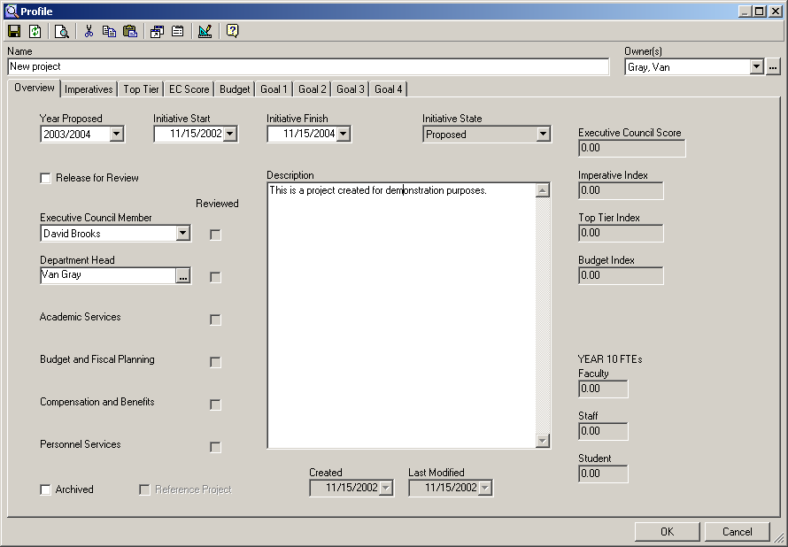

2012 Imperatives

This section should provide the justification for your stated degree of impact along each of the twelve Baylor 2012 imperatives.

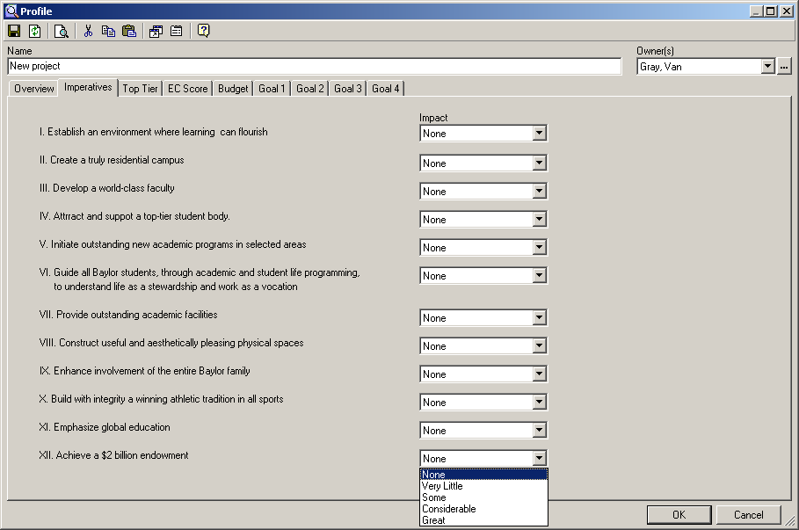

Top Tier Metrics

This section should provide the justification for your stated degree of impact along each of the sixteen Top Tier Metrics. Definitions for each of these can be found in the document entitled “Top Tier Ranking Definitions” in the Linked Documents area of the strategic planning database.

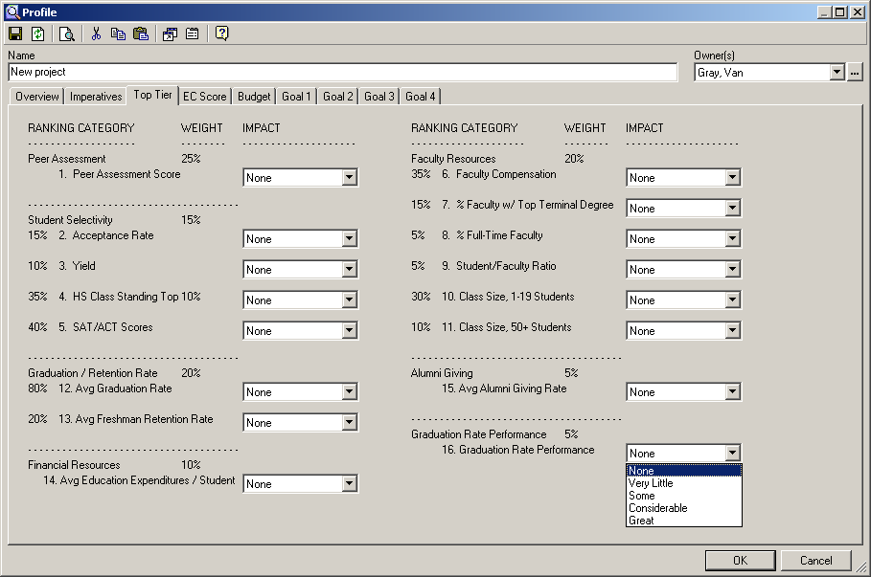

Financial Summary

This section should provide your justification and supporting research for all items included in your budget recommendations. The budget template, when completed, will automatically populate the budget fields with the strategic planning database. However, it is recommended that the supporting research, narrative, external data and underlying analysis regarding your proposal’s Income, Personnel, Capital and Other expenditures, should appear in this section.

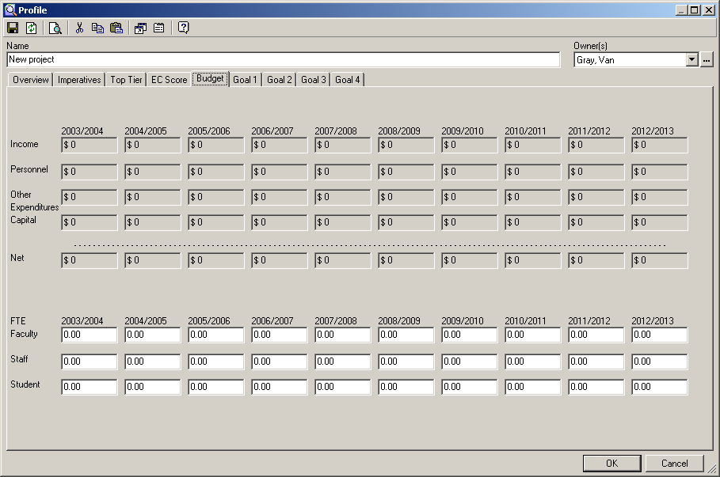

Goals 1 - 4

- This section should provide your justification for the following:

  - Not more than four statements (called ‘goals’) that are necessary to the overall achievement of your initiative. (These should be the four most important items required for the success of your initiative).
  - A target date for the attainment of the stated goal.
  - For each of the goals, not more than four measures of performance. (These metrics are the indicators of having achieved the goal, or they are the measure of the benefits associated with the attainment of the goal).

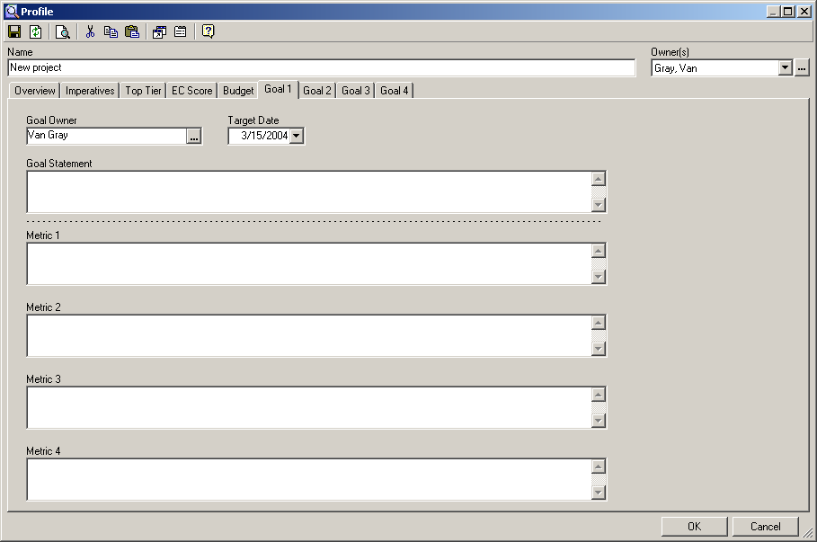

Exit Strategy

This section should provide a discussion of a proposed course of action (or optional actions) to take in the event that your proposal does not meet its stated goals during its implementation.

Appendix

Include in this section any additional information that you believe will strengthen your request for funding.

